# The relationship between rice production quantity and mean monthly temperature/ mean monthly precipitation/ agriculture land size in global

Ching-Min Hu

In this project, I want to analyze the factors of rice production quantity with mean monthly temperature, mean precipitation, and agriculture land size by data visualization.

## Tool

Tableau Desktop, Tableau Prep, Python

## Data

1. rice annual production from 1961 to 2019.

Source: [http://www.fao.org/faostat/en/#data/QCL](http://www.fao.org/faostat/en/" \l "data/QCL)

columns:

* Domain Code: string, code of domain.
* Domain: string, category of data, in this project, only “Crops and livestock products”.
* Area Code (ISO3): string, country code in ISO3.
* Area: string, country name.
* Element Code: int, code of element.
* Element: string, subcategory of item, in this project, only “Production”
* Item Code (FAO): int, code of item.
* Item: string, the item which want to search, in this project, only “Rice, paddy”.
* Year Code: int, the year of statistical figures.
* Year: int, same as “Year Code”.
* Unit: string, the unit of “Value”. In this project, only “tones”.
* Value: float, the number of items.
* Flag: string, code of “Flag Description”.
* Flag Description: string, source of statistic figure.

1. Mean monthly temperature from 1901 to 2020.

Source: <https://climateknowledgeportal.worldbank.org/download-data>

columns:

* Temperature - (Celsius): float, mean monthly temperature in each month and year (Celsius).
* Year: int, the year of statistical figures.
* Statistics: float, the month of statistical figures.
* Country: string, country name.
* ISO3: string, country code in ISO3.

1. Average precipitation in depth (mm per year) from 1900 to 2014.

Source: <https://data.worldbank.org/indicator/AG.LND.PRCP.MM?most_recent_year_desc=false>

columns:

* Entity: string, country name.
* Code: string, country code in ISO3.
* Year: int, the year of statistical figures.
* Average monthly precipitation: float, average precipitation (mm).

1. Agriculture land from 1961 to 2018

source: <https://data.worldbank.org/indicator/AG.LND.AGRI.ZS>

columns:

* Country Name: string, country name.
* Country Code: string, country code in ISO3.
* Indicator Name: string, data category, in this data, only “Agricultural land (% of land area)”.
* Indicator Code: string, code of “Indicator Name”.
* 1960 - 2020: float, total 61 columns, the column names are represented as years, the data in it is the percentage of agricultural land of the whole country land.

1. Land Area from 1961 to 2018

source: <https://data.worldbank.org/indicator/AG.LND.TOTL.K2?most_recent_value_desc=true>

columns:

* Country Name: string, country name.
* Country Code: string, country code in ISO3.
* Indicator Name: string, data category, in this data, only “Land area (sq. km)”.
* Indicator Code: string, code of “Indicator Name”.
* 1960 - 2020: float, total 61 columns, the column names are represented as years, the data in it is the area of country land (sq km).

## Data Processing

I process the data by python and Tableau Prep.

Figure 1 is the structure of Tableau flow. The dataset from up to down are: Land Area, Agriculture land, Average precipitation, Mean monthly temperature, and rice annual production.

In Land Area, and Agriculture land, the columns are so many, I apply python code to pivot as [country name, country code, year, per/land].

In the rice production dataset, it contains the USSR and Yugoslav. These two are historical countries, and in land/agriculture/In Average precipitation/Mean monthly temperature dataset are all separate as many countries as current, so I combine the countries which belong to these two until 1991.

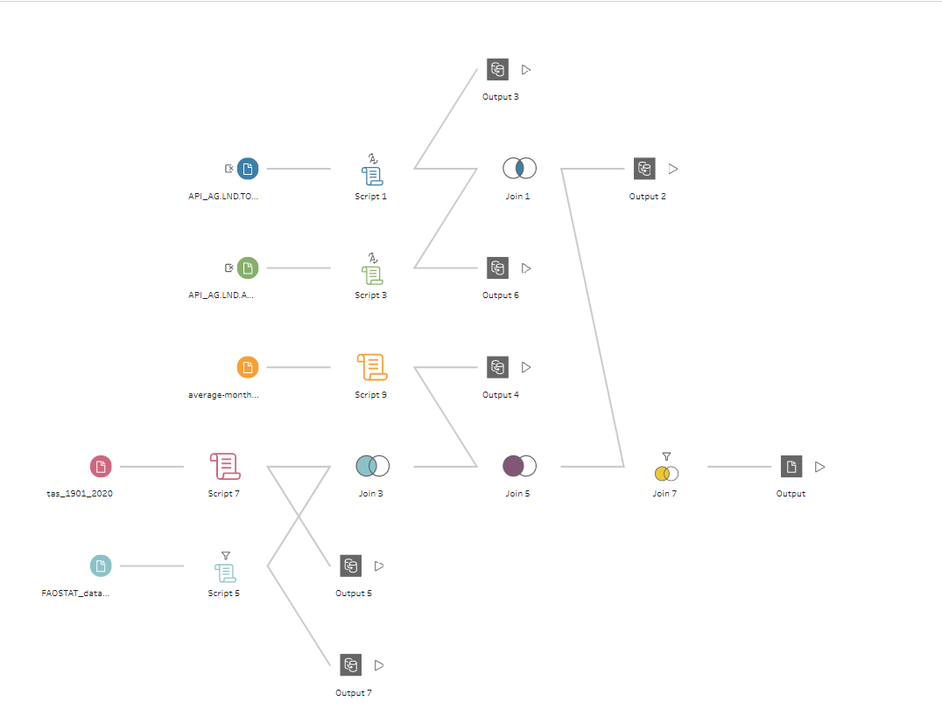

Figure 1 Tableau flow structure

From tableau prep, I export 4 hyper databases. In Tableau, I join them as figure 2.



Figure 2 Table join in Tableau

some calculations create in Tableau

* continent: classify each country to Asia/ Europe/ America/ Oceania/ Africa
* Asia_region: classify each country in Asia to East/ Southeast/ South/ West/ North/ Central Asia
* America_region: classify each country in Asia to North/ Latin/ South America
* agri_area: calculate agriculture land size.
* amount: since if the temperature data is available in specific country and year, the same annual rice produce figure would appear 12 times. In order not to calculate repeatedly, set formula as

**IIF(ISNULL([Statistics]),[Value],{ FIXED [Area_Code],[year]: AVG([Value])})**

* amount_sqkm: the tonnes of rice produced in a square kilometer.
* amount_temp: the total amount in a specific temperature.
* area_step: the agricultural land of each country is different, so I managed them by steps. Each step is 100000 square kilometer. [0,100000],(100000,200000]....
* avg_temp_year: calculate average yearly temperature for each country.
* top_temp: calculate max temperature in a year for each country.

## Data Visualization and Analysis

1. In the map (Figure 3a), the circle size represents the average of annual rice production from 1961 to 2019. We can find rice grown in many countries, while Asia(East, Southeast, and south), United States, and Brazil produce the most proportion of rice globally. In Figure 3b, it shows the change of rice amount yearly. Especially, United States and Pakistan have grown dramatically during these 5 decades. In Figure 4, we can also find, Asia grows more than 80% of rice globally while Oceania produces very rarely.

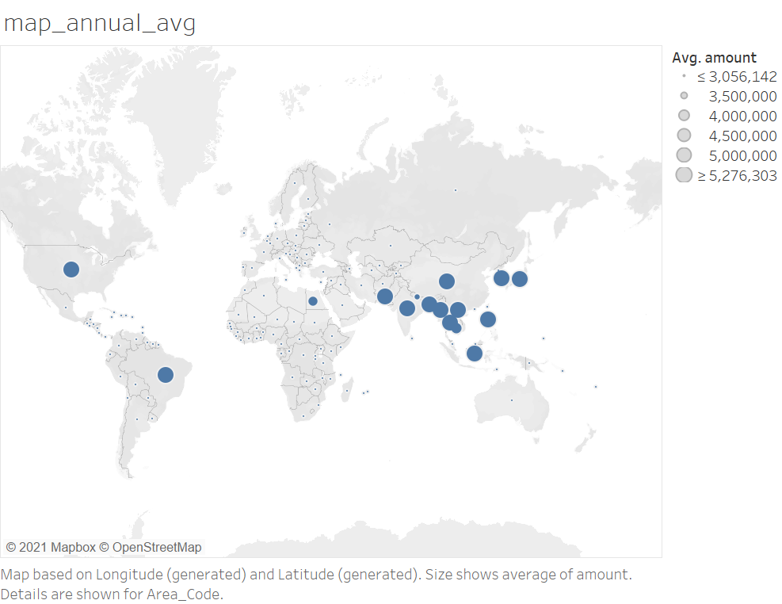

Figure 3a. Mean annual production in each country



Figure 3b. Mean annual production in each country for each year

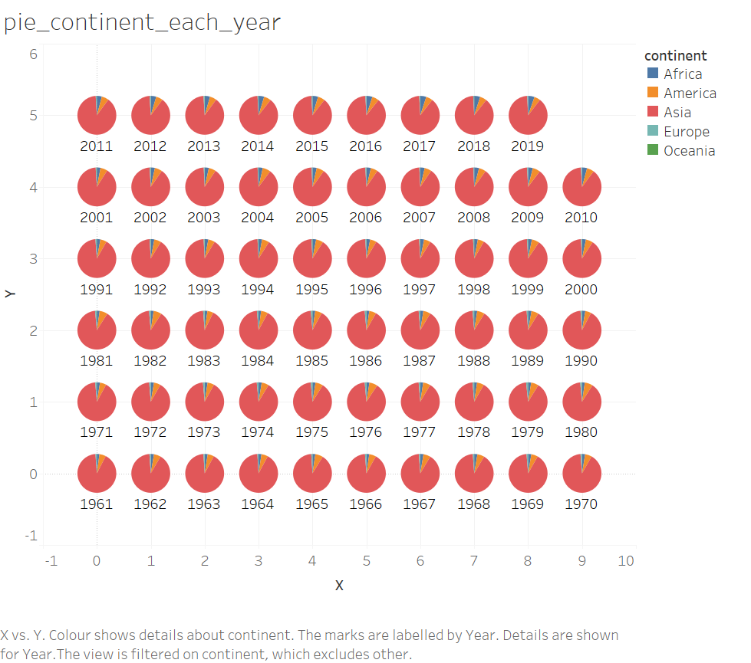

Figure 4. Pie chart for rice yield in 5 continents for each year

1. In Figure 5, it shows the annual amount from 1961 to 2019. The yield for rice in recent years has grown 3 times since 1960.

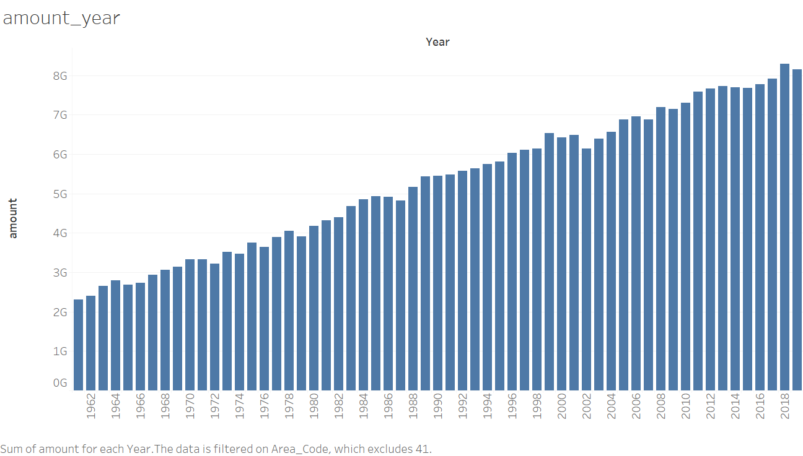

Figure 5. Rice annual yield (tonnes)

1. The relationship between mean annual temperature. In Figure 6a, it’s hard to say that temperature has a high relationship with rice production. It only shows if temperatures in [6,8] and [22,30] have a high chance to grow more rice. In Figure 6b, I observe the data by continent. Europe can produce rice at a wide temperature interval, but converge to [8,13] Celsius. Asia and America have two high peaks. Africa and Oceania converge to about 25 Celsius. Consider the situation in Asia and America are complex. I separate Asia into East/ Southeast/ South/ West/ North/ Central Asia, and America to North/ Latin/ South America. In Figure 6c, Central and West Asia also produce rice at a wide temperature interval, but it can also converge to a temperature range. East Asia converges to about 7 Celsius, while southeast and south Asia to 25. In figure 6d, Latin and south America converge to about 25 Celsius while north converge to 7.

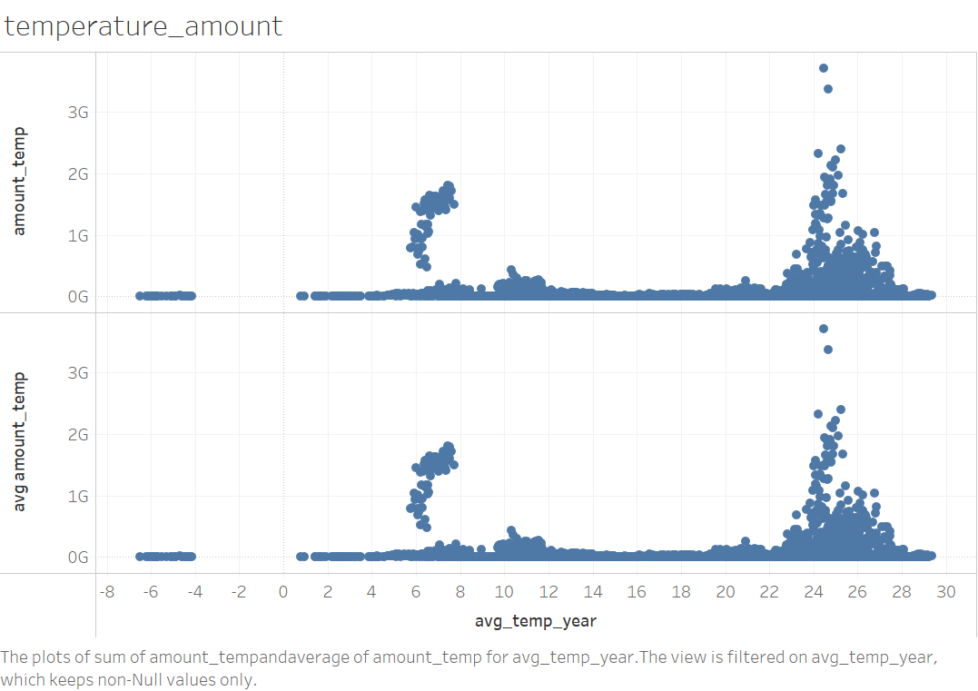

Figure 6a. Total amount/ average amount of rice for each average temperature



Figure 6b. Total / average amount of rice for each average temperature by continent.



Figure 6c. Total /average amount of rice for each average temperature by Asia region.



Figure 6d. Total / average amount of rice for each average temperature by America region.

1. The relationship between highest mean monthly temperature. In Figure 7a, it’s also hard to say that the hottest month's temperature has a high relationship with rice production. It only shows if temperatures in [18,22] and [26,30] have a high chance to grow more rice. In Figure 7b, I observe the data by continent, Europe, Africa, and Oceania, are all separated in a wide temperature interval and converge to a range, while Asia and America have some high peaks. In figure 7c, east Asia converges to about 20 Celsius while other regions to around 30. In figure 7d, north America converge to 20 while others to 26. 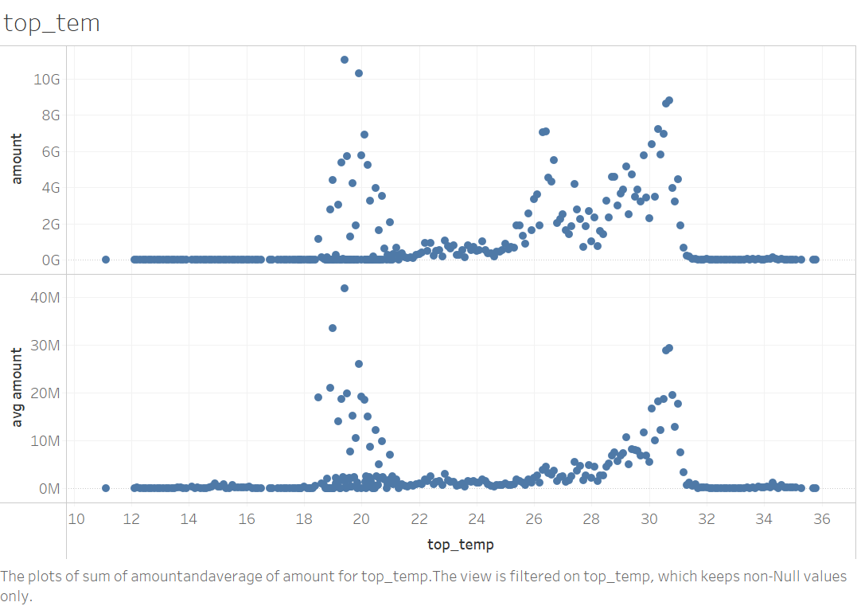

Figure 7a. Total amount/ average amount of rice for each top temperature



Figure 7b. Total amount/ average amount of rice for each top temperature by continent



Figure 7c. Total amount/ average amount of rice for each top temperature by Asia regions



Figure 7d. Total /average amount of rice for each top temperature by America regions

1. The relationship between mean monthly precipitation. In Figure 8a, it’s hard to say that precipitation has a high relationship with rice production. It only shows if temperatures in [4, 12] have a high chance to grow more rice. In Figure 8b, I observe the data by continent, Europe, Oceania, America, Africa can produce rice at a wide precipitation interval. Asia converges to [5,10] mm. Since the scatter in Asia is more complex than others, I explore Asia in 5 regions. In Figure 8c, Central, West, and East Asia converge to about 5 mm. The precipitation interval in the other 2 regions is wide but in south Asia coverage is 10 mm. In southeast Asia, the amount can reach 1000M in the whole interval. In figure 8d, north America is to 6mm, while other two regions are to about 15.

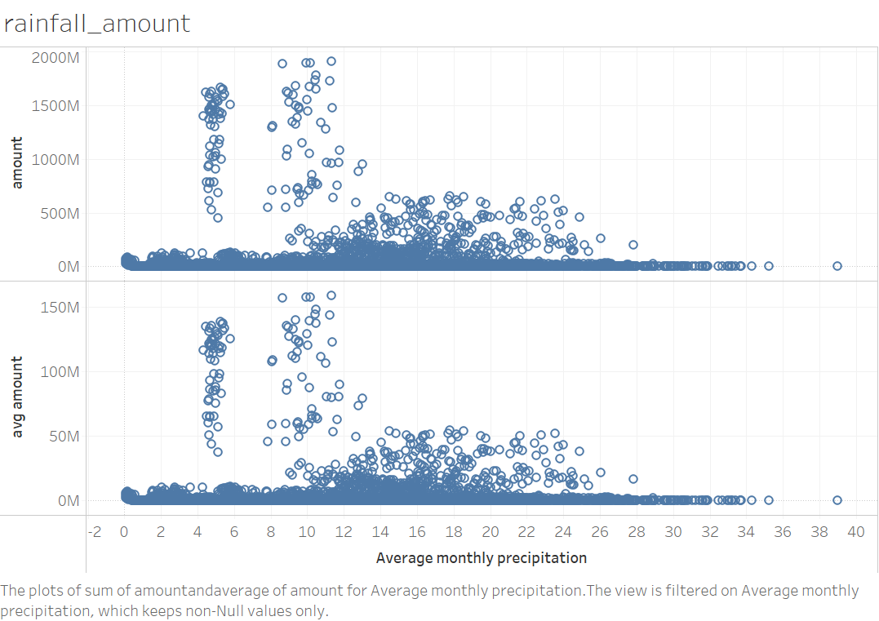

Figure 8a. Total / average amount of rice for each average precipitation



Figure 8b. Total / average amount of rice for each average precipitation by continent



Figure 8c. Total / average amount of rice for each average precipitation by Asia region



Figure 8d. Total / average amount of rice for each average precipitation by America region

1. Consider both the hottest month temperature and precipitation. In figure 9a, the circle size means the average amount from 1961 to 2014, if the number is closer to 0 the color is darker in red while darker in blue in opposite. There are two sections that produce more rice: (19-21 Celsius, 5 mm) and (30 Celsius, 8-13 mm). In figure 9b, Africa and America grow the rice in both the wide hottest temperature and precipitation interval and each condition grows less. Europe grows in the wide hottest temperature range while Oceania in the wide precipitation range and each condition also grows less. The two high produce sections found in 9a are in Asia. In 9c, it shows (19-21 Celsius, 5 mm) in East Asia and (30 Celsius, 8-13 mm) in South Asia.

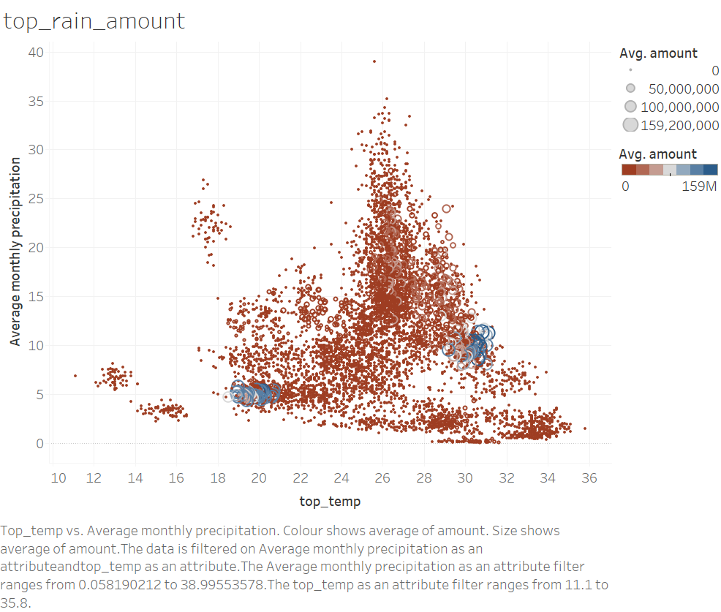

Figure 9a. Rice production in each hottest temperature / Average precipitation



Figure 9b. Rice production in each hottest temperature / Average precipitation by continent



Figure 9c. Rice production in each hottest temperature / Average precipitation by Asia region

1. Consider both the average month temperature and precipitation. In figure 10a, there are two sections that produce more rice: (5-8 Celsius, 5 mm) and (24 Celsius, 8-13 mm). In figure 10b, the result is like 9b. In 10c, it shows (5-8 Celsius, 5 mm) in East Asia and (24 Celsius, 8-13 mm) in South Asia.

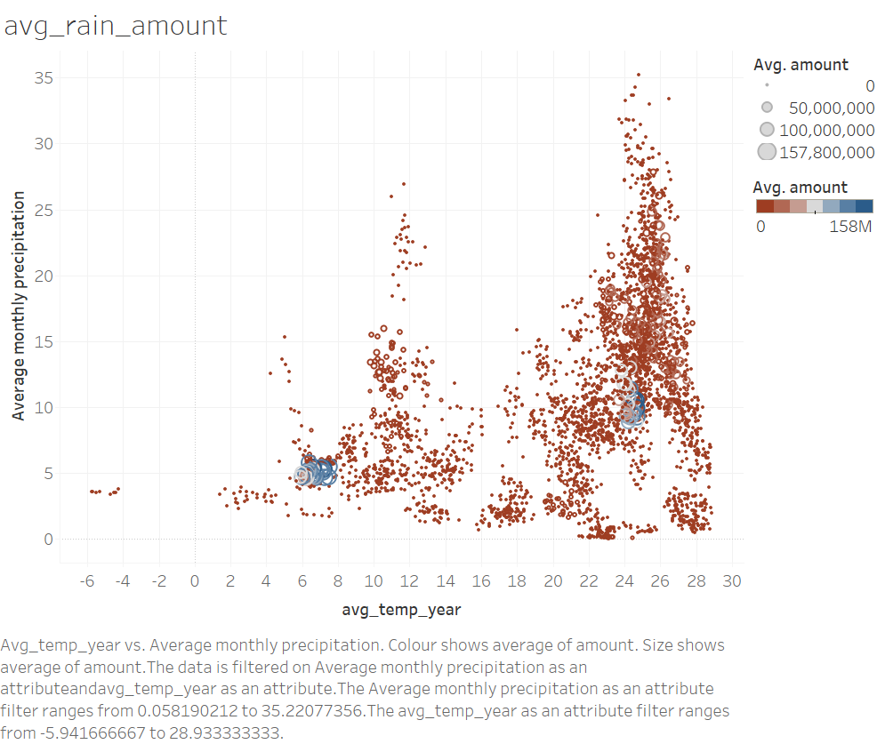

Figure 10a. Rice production in each average temperature / Average precipitation



Figure 10b. Rice production in each average temperature/ average precipitation by continent



Figure 10c. Rice production in each average temperature/precipitation by Asia region

1. Since some temperature/precipitation may have a larger size of agricultural land, it could produce more rice. I then change the measure method to the weight produced per square kilometer in both average temperature and precipitation. The circle size means the weight per unit, if the number is closer to 0 the color is darker in red, otherwise is darker in blue. It’s also distributed in two groups: (10-12 Celsius, 5-25 mm), (24-25 Celsius, 10-25 mm), are in south America, east/ south/ southeast Asia.

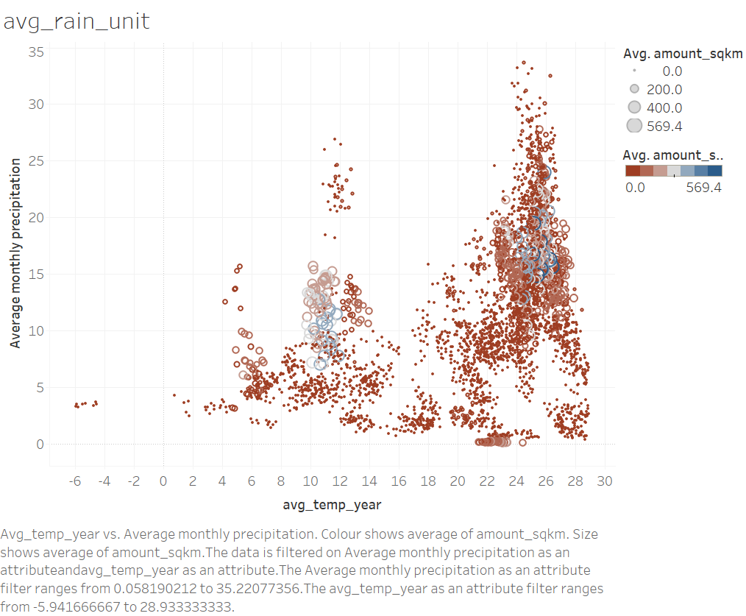

Figure 11a. Unit rice production in each average temperature / Average precipitation



Figure 11b. Unit rice production in each average temperature/ precipitation by continent



Figure 11c. Unit rice production in each average temperature/ precipitation by Asia region



Figure 11d. Unit production in each average temperature/ precipitation by America region

1. With the new measure - production per square kilometer, only consider temperature. in 12a, it shows 3 peaks [5,8], [10,14], [22,28]. In 12b, Africa converges to 23 Celsius, America to 26 Celsius, Oceania and Europe are wide, and Asia has 3 peaks. From 12c, it shows the relation between temperature and unit production in east Asia looks linear. South Asia converges to 25 Celsius and also has the highest unit production in 591.3 tonnes/sq km in Asia. Southeast Asia has the second highest unit production in Asia and the temperature to 24 Celsius. In 12d, the trend growth temperature is similar from 1961 to 2018.

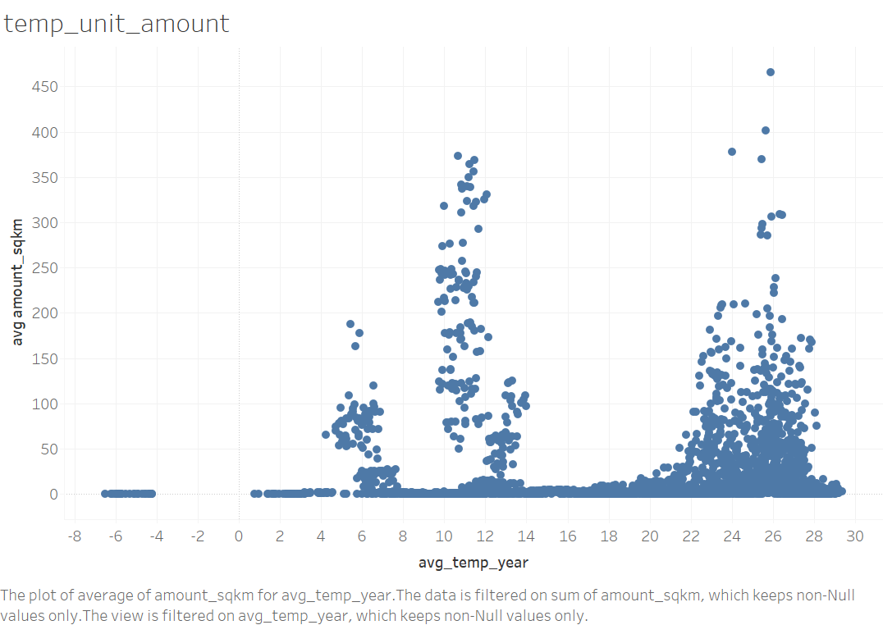

Figure 12a. Unit production in each average temperature



Figure 12b. Unit production in each average temperature by continent



Figure 12c. Unit production in each average temperature by Asia region



Figure 12d. Unit production in each average temperature by year

1. Consider unit production with precipitation. In 13a, the average rainfall converges to 14-18 mm, the highest unit production is 600 tonnes/sq km. In 13b, America converged to 15-20 and the average unit production to 400 tonnes/sq km. Asia reach 600 tonnes/sq km. In 13c, it shows South Asia has the highest produce efficiency.

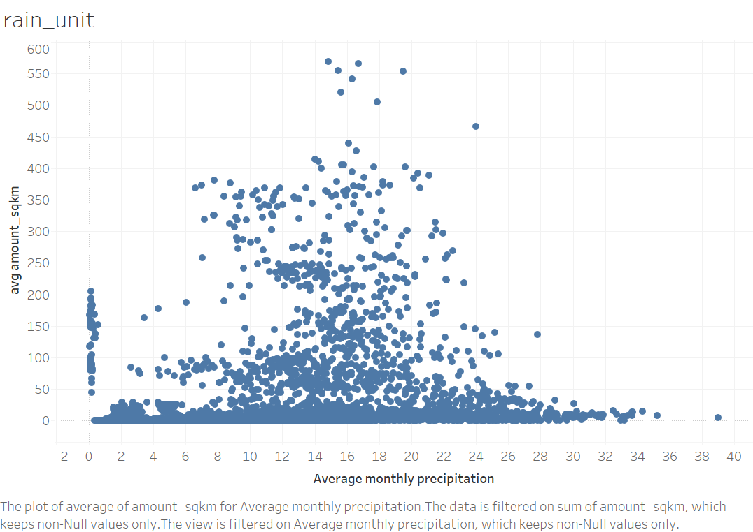

Figure 13a.Unit production in each average precipitation



Figure 13b. Unit production in each average precipitation by continent



Figure 13c. Unit production in each average precipitation by Asia region

1. The agriculture area has been grouped into steps, with each step being 100000 sq km. If the land is greater than 5000000 sq km, the production is greater than others, but the trend is fluctuant (Figure 14a). It’s like the normal distribution in America, and in Asia, east Asia, and southeast Asia, if the agricultural land size is greater than 3400000 sq km, if the land size is larger than the production is more (Figure 14b, 14c). It’s interesting to see that the agricultural land which is larger than 4100000 sq km is less use in grow the rice (Figure 14d).

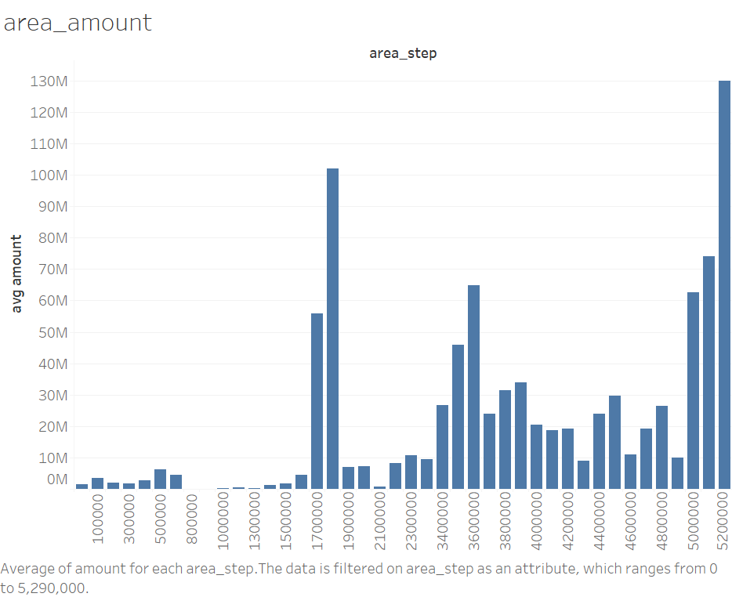

Figure 14a. Rice production in each area section



Figure 14b. Rice production in each area section by continent



Figure 14c. Rice production in each area section by Asia region



Figure 1db. Rice production in each area section by year

## Conclusion

1. From 1960 to 2019, rice production increased gradually. Asia produced most of the rice in these 50 years. Rice is mainly from east Asia, southeast Asia, south Asia, United State, Brazil, and Nigeria. The Unit production trend is similar in these 5 decades.
2. From table 1 to 8, the best condition (can produce the highest amount of rice or can have the highest unit production) is different in different areas. Especially in Asia and America, the situation is more complex than other areas.

|  |  |  |  |
| --- | --- | --- | --- |
|  | Hottest month (Celsius) | Mean temperature (Celsius) | Average monthly precipitation (mm) |
| Asia | Some peaks | Two peaks | 5-10 |
| Africa | 30 | 25 | 8 |
| Europe | 21-23 | 8,13 | 4 |
| America | Two peaks | Two peaks | Two peaks |
| Oceania | 28 | 24 | 4 |

Table 1. hottest/mean temperature, average precipitation when rice produce most by continent

|  |  |  |  |
| --- | --- | --- | --- |
|  | Hottest month (Celsius) | Mean temperature (Celsius) | Average monthly precipitation (mm) |
| Central | 28 | 8 | 2 |
| East | 19 | 7 | 5 |
| South | 31 | 24 | 10 |
| Southeast | 27 | 25 | 12-24, wide |
| West | 29 | 24 | 2 |

Table 2. hottest/mean temperature, average precipitation when rice produce most by Asia region

|  |  |  |  |
| --- | --- | --- | --- |
|  | Hottest month (Celsius) | Mean temperature (Celsius) | Average monthly precipitation (mm) |
| Latin | 26-28 | 24 | 10-14 |
| North | 20 | 7 | 6 |
| South | 26 | 25 | 14-16 |

Table 3. hottest/mean temperature, average precipitation when rice produce most by America region

|  |  |  |
| --- | --- | --- |
|  | Hottest/ avg precipitation | avg/ avg precipitation |
| Global | (19-21 Celsius, 5 mm)  (30 Celsius, 8-13 mm) | (5-8 Celsius, 5 mm)  (24 Celsius, 8-13 mm) |
| East Asia | (19-21 Celsius, 5 mm) | (5-8 Celsius, 5 mm) |
| South Asia | (30 Celsius, 8-13 mm) | (24 Celsius, 8-13 mm) |

Table 4. (hottest/mean temperature, average precipitation) when rice produce most

|  |  |
| --- | --- |
|  | mean temperature/ avg precipitation |
| Global | (10-12 Celsius, 5-25 mm)  (24-25 Celsius, 10-25 mm) |
| South America | (25 Celsius, 15-25 mm) |
| East Asia | (10-12 Celsius, 5-15 mm) |
| South Asia | (25 Celsius, 15-25 mm) |
| Southeast Asia | (24 Celsius, 10-20 mm) |

Table 5. (Mean temperature, average precipitation) when unit rice produces most

|  |  |  |
| --- | --- | --- |
|  | Mean temperature (Celsius) | Average monthly precipitation (mm) |
| Asia | Two peaks | 14-16 |
| Africa | 23 | Flat |
| Europe | 12 | 8 |
| America | 26 | 15-20 |
| Oceania | 25.5 | 24-26 |

Table 6. mean temperature, average precipitation when unit rice produces most by continent

|  |  |  |
| --- | --- | --- |
|  | Mean temperature (Celsius) | Average monthly precipitation (mm) |
| Central | 4 & 12 | 2 |
| East | Linear 11.5 | 7-13 |
| South | 25 | 14-18 |
| Southeast | 24 | 14-18 |
| West | 18 & 21 | 2 |

Table 7. mean temperature, average precipitation when unit rice produce most by Asia region

|  |  |  |
| --- | --- | --- |
|  | Mean temperature (Celsius) | Average monthly precipitation (mm) |
| Latin | 24.5 | 10-14 |
| North | 8 | 5-6 |
| South | 26 | 18-20 |

Table 8. mean temperature, average precipitation when unit rice produces most by America region

1. Agriculture area size could be an important factor of rice production.